Issues with the Git hub, did not let me commit all of the changes I completed over time so I created a new branch and merged it the fixes.

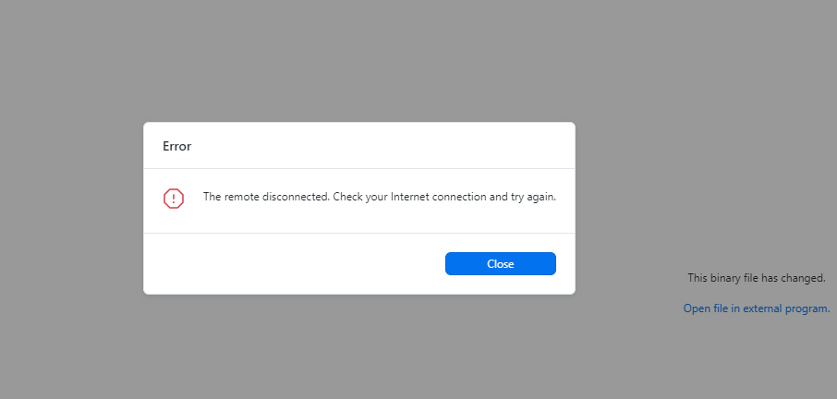

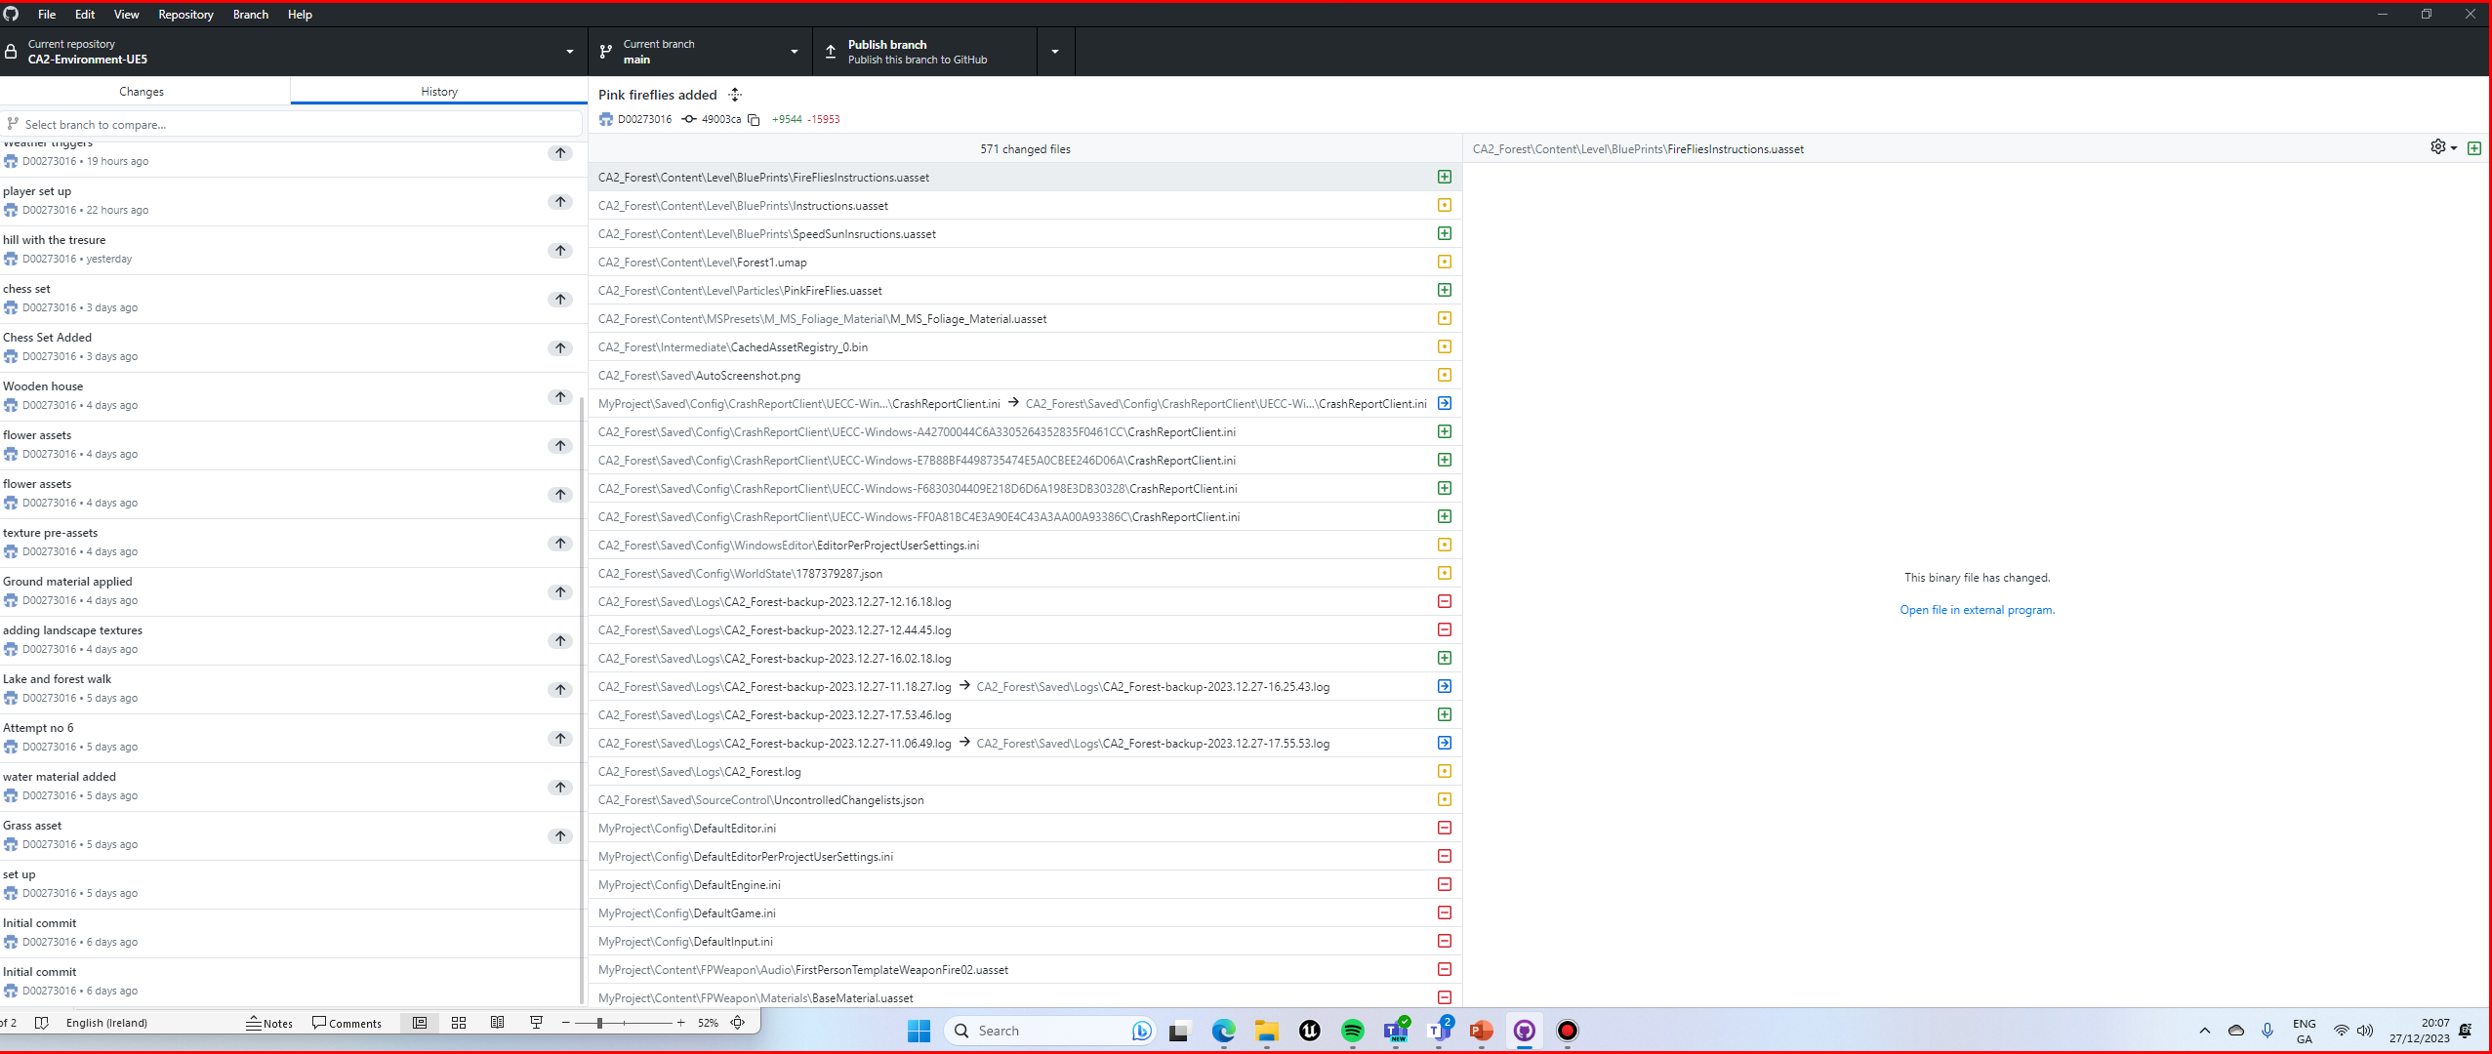

References:

[[UE5 Niagara] How to make SNOW easily! (youtube.com)](https://www.youtube.com/watch?v=8BCLmjifdDw)

[HOW TO MAKE RAIN | UNREAL ENGINE TUTORIAL (youtube.com)](https://www.youtube.com/watch?v=wkI7EBJ6mK8)

[(5) Unreal Engine 5 - Create a day night cycle in 90 seconds - YouTube](https://www.youtube.com/watch?v=UZSRtwIa3Ls)

[Unreal5 Niagra VFX: Floating Ember/Dust Particles (youtube.com)](https://www.youtube.com/watch?v=1n1q4kQ9Ehg&list=LL&index=9)

<https://www.youtube.com/watch?v=5-UJT4U-jeg>